**PIZZA SALES SQL QUERIES**

**1. KPI’s**

**a) Total Revenue:**

***Querry:***

SELECT SUM(total_price) AS Total_Revenue FROM pizza_sales;

***Output:***

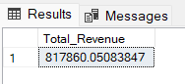

**b) Average Order Value**

***Querry:***

SELECT (SUM(total_price) / COUNT(DISTINCT order_id)) AS Avg_order_Value FROM pizza_sales

***Output:***

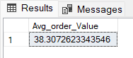

**c) Total Pizzas Sold**

***Querry:***

SELECT SUM(quantity) AS Total_pizza_sold FROM pizza_sales

***Output:***

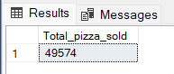

**d) Total Orders**

***Querry:***

SELECT COUNT(DISTINCT order_id) AS Total_Orders FROM pizza_sales

***Output:***

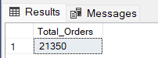

**e) Average Pizzas Per Order**

***Querry:***

SELECT CAST(CAST(SUM(quantity) AS DECIMAL(10,2)) /

CAST(COUNT(DISTINCT order_id) AS DECIMAL(10,2)) AS DECIMAL(10,2))

AS Avg_Pizzas_per_order

FROM pizza_sales

***Output:***

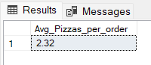

**2. Daily Trend for Total Orders**

***Querry:***SELECT DATENAME(DW, order_date) AS order_day, COUNT(DISTINCT order_id) AS total_orders

FROM pizza_sales

GROUP BY DATENAME(DW, order_date)

***Output:***

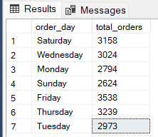

**3. Monthly Trend for Orders**

***Querry:***

select DATENAME(MONTH, order_date) as Month_Name, COUNT(DISTINCT order_id) as Total_Orders

from pizza_sales

GROUP BY DATENAME(MONTH, order_date)

***Output:***

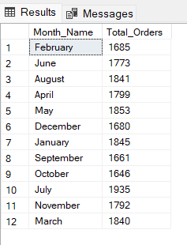

**4. % of Sales by Pizza Category**

***Querry:***

SELECT pizza_category, CAST(SUM(total_price) AS DECIMAL(10,2)) as total_revenue,

CAST(SUM(total_price) * 100 / (SELECT SUM(total_price) from pizza_sales) AS DECIMAL(10,2)) AS PCT

FROM pizza_sales

GROUP BY pizza_category

***Output:***

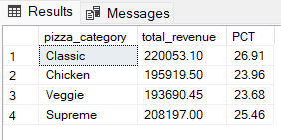

**5. % of Sales by Pizza Size**

***Querry:***

SELECT pizza_size, CAST(SUM(total_price) AS DECIMAL(10,2)) as total_revenue,

CAST(SUM(total_price) * 100 / (SELECT SUM(total_price) from pizza_sales) AS DECIMAL(10,2)) AS PCT

FROM pizza_sales

GROUP BY pizza_size

ORDER BY pizza_size

***Output:***

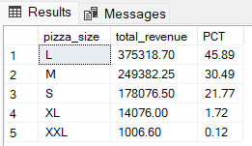

**6. Total Pizzas Sold by Pizza Category**

***Querry:***

SELECT pizza_category, SUM(quantity) as Total_Quantity_Sold

FROM pizza_sales

WHERE MONTH(order_date) = 2

GROUP BY pizza_category

ORDER BY Total_Quantity_Sold DESC

***Output:***

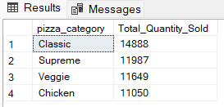

**7. Top 5 Pizzas by Revenue**

***Querry:***

SELECT Top 5 pizza_name, SUM(total_price) AS Total_Revenue

FROM pizza_sales

GROUP BY pizza_name

ORDER BY Total_Revenue DESC

***Output:***

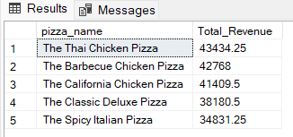

**8. Bottom 5 Pizzas by Revenue**

***Querry:***

SELECT Top 5 pizza_name, SUM(total_price) AS Total_Revenue

FROM pizza_sales

GROUP BY pizza_name

ORDER BY Total_Revenue ASC

***Output:***

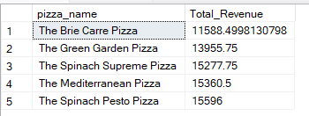

**9. Top 5 Pizzas by Quantity**

***Querry:***

SELECT Top 5 pizza_name, SUM(quantity) AS Total_Pizza_Sold

FROM pizza_sales

GROUP BY pizza_name

ORDER BY Total_Pizza_Sold DESC

***Output:***

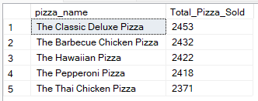

**10. Bottom 5 Pizzas by Quantity**

***Querry:***

SELECT TOP 5 pizza_name, SUM(quantity) AS Total_Pizza_Sold

FROM pizza_sales

GROUP BY pizza_name

ORDER BY Total_Pizza_Sold ASC

***Output:***

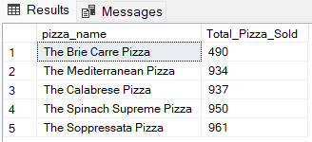

**11. Top 5 Pizzas by Total Orders**

***Querry:***

SELECT Top 5 pizza_name, COUNT(DISTINCT order_id) AS Total_Orders

FROM pizza_sales

GROUP BY pizza_name

ORDER BY Total_Orders DESC

***Output:***

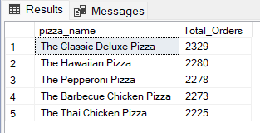

**12. Borrom 5 Pizzas by Total Orders**

***Querry:***

SELECT Top 5 pizza_name, COUNT(DISTINCT order_id) AS Total_Orders

FROM pizza_sales

GROUP BY pizza_name

ORDER BY Total_Orders ASC

***Output:***

